Discusfood
Discus Milenium Ltd,Epidaurou2 ,flat 108,pc:2660 Kokkinotrimithia,Nicosia
Telephone:+35796316020 email:discusmilenium@outlook.com

Price list
Product overview with price list
Artikel-Nr. Item no. | Foto | Beschreibung  Description | sales unit | EAN-Code | MOQ | weight | price
20041 | 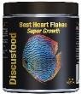 | Best Heart Flakes  Super Growth | 65g | 4260209350566 | 12 | 0,102 | 6,55 €
20042 | 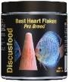 | Best Heart Flakes  Pro Breed | 65g | 4260209350573 | 12 | 0,102 | 6.55€
20043 | 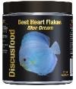 | Best Heart Flakes  Blue Dream | 65g | 4260209350580 | 12 | 0,102 | 6.55 €
20044 | 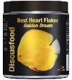 | Best Heart Flake  Golden Dream | 65g | 4260209350597 | 12 | 0,102 | 6,67 €
20045 | 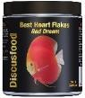 | Best Heart Flake  Red Dream | 65g | 4260209350597 | 12 | 0,102 | 7,94 €
20050 | 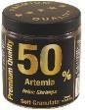 | Artemia 50 %  Soft Granulate | 150g | 4260209350504 | 12 | 0,187 | 14,61 €
20051 | 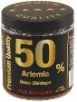 | Artemia 50 %  Flat Granulate | 65g | 4260209350511 | 12 | 0,102 | 9,55 €
20052 | 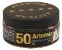 | Artemia 50 %  Microgranulate Soft | 45g | 4260209350528 | 12 | 0,07 | 6,47 €
20053 | 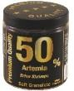 | Artemia 50 % XL  Soft Granulate | 150g | 4260209350535 | 12 | 0,187 | 14,61€
22060 | 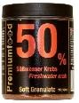 | Freshwater Crab 50 %  Soft Granulate | 150g | 4260209351013 | 6 | 0,187 | 13,19 €
22062 | 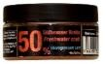 | Freshwater Crab 50 %  Microgranulate Soft | 45g | 4260209351044 | 12 | 0,07 | 6,30 €
22063 | 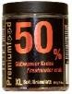 | Freshwater Crab 50 % XL  Soft Granulate | 150g | 4260209351051 | 12 | 0,187 | 13,19 €

20057 | 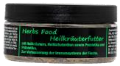 | Herbs Food | 30g | 4260209351068 | 5 | 0,055 | 5,74 €
20059 | 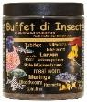 | "Buffet Di Insect"  Flat Granulate | 65g | 4260209351594 | 12 | 0,102 | 10,01 €
20060 | 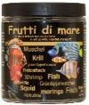 | "Frutti Di Mare"  Flat Granulate | 65g | 4260209350665 | 12 | 0,102 | 10,01 €
20061 | 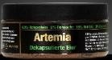 | Brine Shrimps  Decapsulated Eggs | 65g | 4260209350610 | 5 | 0,09 | 13,49 €
20062 | 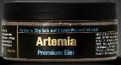 | Brine Shrimps  Premium Eggs | 50g | 4260209350627 | 5 | 0,08 | 26,07€
20071 | 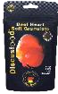 | Beef Heart  Soft Granulate | 80g | 4260209350719 | 20 | 0,09 | 4,65€
20712 | 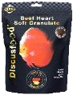 | Beef Heart  Soft Granulate | 230g | 4260209357121 | 10 | 0,25 | 10,89 €
20711 | 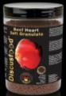 | Beef Heart  Soft Granulate | 550g | 4260209357183 | 5 | 0,6 | 21,75 €
20715 | 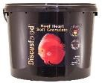 | Beef Heart  Soft Granulate | 2800g | 4260209357152 | 1 | 3 | 108,33 €
20055 | 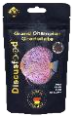 | Grand Champion  Granulate | 80g | 4260209350559 | 20 | 0,09 | 4,41 €
20552 | 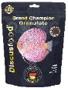 | Grand Champion  Granulate | 230g | 4260209355523 | 10 | 0,25 | 10,55 €
20064 | 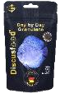 | Day by Day  Granulate | 80g | 4260209350641 | 20 | 0,09 | 3.65 €
20642 | 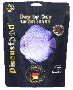 | Day by Day  Granulate | 230g | 4260209356421 | 10 | 0,25 | 8,33 €
20645 | 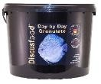 | Day by Day  Granulate | 2800g | 4260207356452 | 1 | 3 | 83,61 €
20070 | 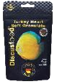 | Turkey Heart  Soft Granulate | 80g | 4260209350702 | 20 | 0,09 | 4,65 €
20702 | 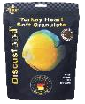 | Turkey Heart  Soft Granulate | 230g | 4260209350993 | 10 | 0,25 | 10,88 €

20076 | 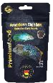 | American Cichlid  Spirulina Pearls | 80g | 4260209350764 | 20 | 0,09 | 4,73 €
20077 | 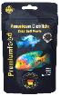 | American Cichlid  Colour Pearls | 80g | 4260209350771 | 20 | 0,09 | 4,73 €
20078 | 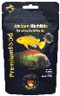 | African Cichlid  Spirulina Pearls | 80g | 4260209350788 | 20 | 0,09 | 4,73 €
20079 | 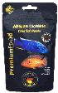 | African Cichlid  Colour Pearls | 80g | 4260209350795 | 20 | 0,09 | 4,73 €
20030 | 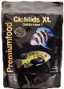 | Cichlids XL  Granulate Comp. 1 | 500g | 4260209350207 | 5 | 0,52 | 25,23 €
20031 | 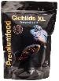 | Cichlids XL  Granulate Comp. 2 | 500g | 4260209350214 | 5 | 0,52 | 25,23 €
20001 | 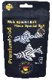 | Pleco Special  Soft Granulate | 80g | 4260209350016 | 20 | 0,09 | 4,65€
20012 | 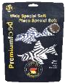 | Pleco Special  Soft Granulate | 230g | 4260209350979 | 10 | 0,25 | 10,88€
20112 | 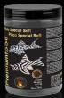 | Pleco Special  Soft Granulate | 550g | 4260209351211 | 5 | 0,6 | 21,75 €
20082 | 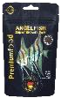 | Angelfish Super Growth  Soft Granulate | 80g | 4260209350825 | 20 | 0,09 | 4,73€
20822 | 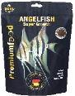 | Angelfish Super Growth  Soft Granulate | 230g | 4260209350986 | 10 | 0,25 | 11,49 €
20823 | 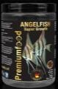 | Angelfish Super Growth  Soft Granulate | 550g | 4260209351198 | 5 | 0,6 | 21,75 €
20073 | 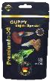 | Guppy Super Special  Soft Granulate | 80g | 4260209350733 | 20 | 0,09 | 5,23 €
27475 | 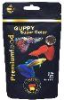 | Guppy Super Color  Soft Granulate | 80g | 4260209354755 | 20 | 0,09 | 5,23€
20080 | 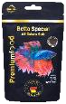 | Betta Special all Colors  Soft Granulate | 50g | 4260209350801 | 20 | 0,06 | 3,59 €
23001 | 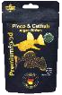 | Pleco & Catfish  Algae Wafers | 50g | 4260209353017 | 20 | 0,06 | 4,08 €

23012 | 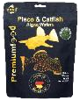 | Pleco & Catfish  Algae Wafers | 150g | 4260209353116 | 10 | 0,165 | 8,73 €
23112 | 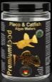 | Pleco & Catfish  Algae Wafers | 480g | 4260209351228 | 5 | 0,52 | 24,15 €
23002 | 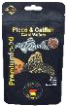 | Pleco & Catfish  Carni Wafers | 50g | 4260209353024 | 20 | 0,06 | 3,84 €
23022 | 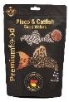 | Pleco & Catfish  Carni Wafers | 150g | 4260209353222 | 10 | 0,165 | 8,31 €
23122 | 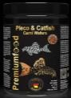 | Pleco & Catfish  Carni Wafers | 500g | 4260209351235 | 5 | 0,55 | 22,60 €
20083 | 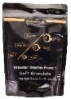 | Breeder Starter  Food I | 500g | 4260209350832 | 5 | 0,525 | 16,39 €
20084 | 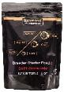 | Breeder Starter  Food II | 500g | 4260209350849 | 5 | 0,525 | 16,39 €
20288 | 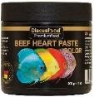 | Beef Heart Paste  Color | 200g | 4260209352881 | 5 | 0,23 | 16,47 €
20289 | 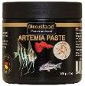 | Brine Shrimp /  Artemia Paste | 200g | 4260209352898 | 5 | 0,23 | 16,47 €
20293 | 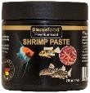 | Shrimp Paste | 200g | 4260209352935 | 5 | 0,23 | 16,47 €
25105 | 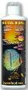 | Natural Humin | 500ml | 4260209355158 | 10 | 0,57 | 10,11 €
25150 | 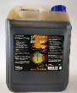 | Natural Humin | 5000ml | 4260209359569 | 1 | 5,3 | 72,90 €
25305 | 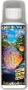 | Amazon Tonic | 500ml | 4260209350054 | 10 | 0,57 | 10,11 €
25350 | 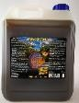 | Amazon Tonic | 5000ml | 4260209359576 | 1 | 5,3 | 72,90 €
25405 | 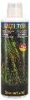 | Anti Tox | 500ml | 4260209359545 | 10 | 0,57 | 10,11 €
25505 | 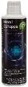 | Catappa Royal | 500ml | 4260209355059 | 10 | 0,57 | 10,11€

25550 | 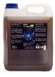 | Catappa Royal | 5000ml | 4260209355509 | 1 | 5,7 | 72,90 €
31000 | 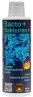 | Bacto+ | 500ml | 4260209354090 | 10 | 0,57 | 14,13 €
31001 | 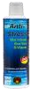 | Anti Stress | 500ml | 4260209354106 | 10 | 0,57 | 14,79 €
33020 | 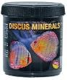 | Discus Minerals | 300g | 4260209350184 | 10 | 0,35 | 11,74 €
33050 | 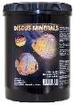 | Discus Minerals | 1000g | 4260209350191 | 3 | 1,12 | 33,30 €
31002 | 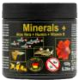 | Minerals + Aloe Vera | 150g | 4260209354113 | 10 | 0,18 | 8,49 €
31005 | 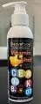 | Vitamin Shot | 150 ml | 4260209355516 | 5 | 0,2 | 9,13 €
32010 | 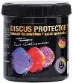 | Discus Protector | 160g | 4260209350177 | 10 | 0,22 | 18,84 €
32030 | 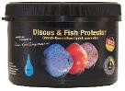 | Discus Protector | 480g | 4260209350030 | 5 | 0,565 | 23,65 €
30085 | 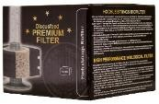 | Bio Ceramic Filter  150L | 1 pc. | 4260209350856 | 10 | 0,36 | 12,40 €
30086 | 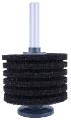 | Bio Ceramic Filter  350L | 1 pc. | 4260209350863 | 10 | 0,535 | 18,37 €

